Using this optical remote control, you can switch on/off any electrical or electronic load. Like any remote control system, it has a mini transmitter unit (Fig. 1) and a receiver unit (Fig. 2) to activate the relay.
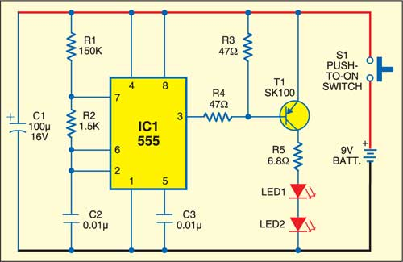
Fig. 1: Transmitter circuit
The optical transmitter used is an astable multivibrator based on IC 555. Its frequency is 1 kHz. At the output of the transmitter, two high-intensity red LEDs driven by a pnp transistor are used. When the optical transmitter is switched on, the red LEDs glow. The emitted red light contains 1kHz code signal.
The optical transmitter works off a 9V PP3 battery. To achieve better performance and longer range, use a reflector in torch.
The receiver unit comprises a signal amplifier, switching circuit, flip-flop and relay. The signal (tone) amplifier boosts 1kHz audio frequency signals. The switching circuit applies pulse to the flip-flop circuit built around STMicroelectronics-make CMOS IC 4027.
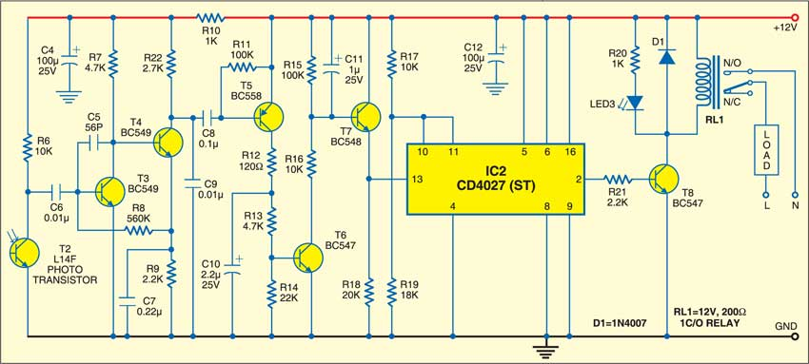
Fig. 2: Receiver circuit
For each input pulse, the output of CD4027 goes high and low alternately. High-to-low variations of the flip-flop are amplified by an npn transistor to energise the relay, which, in turn, controls the external load.
Use regulated 12V to power the receiver unit.
After connecting 12V DC supply to the receiver unit, orient LEDs used in the transmitter towards the sensor of the receiver (L14F). Press switch S1 of the transmitter momentarily. This will activate the relay. Pressing switch S1 again will deactivate the relay.
This optical remote control works satisfactorily in medium-lit and dark rooms.


Briefcase Alarm
D. Mohan Kumar

This miniature alarm unit protects your valuables from theft by sounding an alarm when somebody attempts to pick up your briefcase. It is a battery-operated gadget that can be hidden in a corner inside the briefcase. The circuit uses few components and is simple to fabricate.
The main component of the circuit is a piezo-element used in buzzers. The piezo-element generates electric signals in response to pressure or vibration. It has capacitance of a few tens of nanofarads (nF). Like a capacitor, the piezo-element readily charges when a potential is applied and holds the charge until it is mechanically disturbed. Any mechanical vibration will rearrange the charge on the piezo-electric material with the release of energy.
The voltage developed across the piezo-sensor triggers IC LM358, which is used as a low-power transducer amplifier. IC LM358 works off 9 volts and has two independent high-gain op-amps with large DC gain of 100 dB.
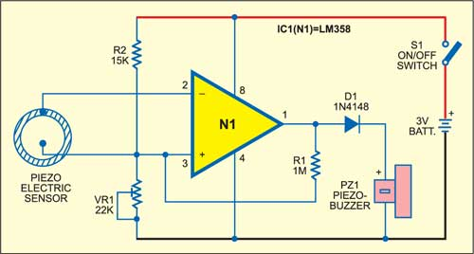
Here the IC is configured as an inverting Schmitt trigger to convert input signals into a shaped output waveform. Preset VR1 sets a threshold voltage at the non-inverting input threshold of IC1. One end of feedback resistor R1 is connected to the output of the IC and the other end to the non-inverting input (pin 3) while the piezo-sensor is connected between the inverting and non-inverting pins.
When the signal from the piezo-sensor is low (standby mode), the output of IC1 is also low. Feedback resistor R1 pulls the non-inverting input voltage above the upper threshold voltage (UTV) of around 1.8 volts.
When the piezo-sensor is touched momentarily, it discharges the stored charge and the inverting input voltage exceeds the positive input and the output goes low. When this happens, the voltage at the positive input falls through VR1 to reach the lower threshold voltage (LTV). At this moment, the voltage at the inverting input is low due to the absence of the input signal. This causes the output to go high and the buzzer beeps.
The output of the IC falls when the input exceeds the UTV and rises when the input drops below the LTV. The difference between the UTV and the LTV is the hysteresis of the Schimdt trigger.
When the piezo-sensor is touched, the buzzer beeps for a few seconds even if the hand is withdrawn. This is because once the output swings high, any slight decrease in voltage at the negative input has no effect. Once begun, the change in state cannot be easily reversed.
Assemble the circuit on a general-purpose PCB as compact as possible and house in a small case. The piezo-sensor should be the smallest one with 10-15mm diameter. Connect it to the unit using a thin, shielded wire and glue on the lower side of the handle of the briefcase. A 3V battery is sufficient to power the circuit.

Simple Automatic Water-Level Controller
Sunil Kumar

Water-level controllers are common nowadays. The one described here is built around timer NE555 and inverter buffer CMOS IC CD4049. It uses readily-available, low-cost components, and is easy to build and install on the over-head tank (OHT) to prevent wastage of water.
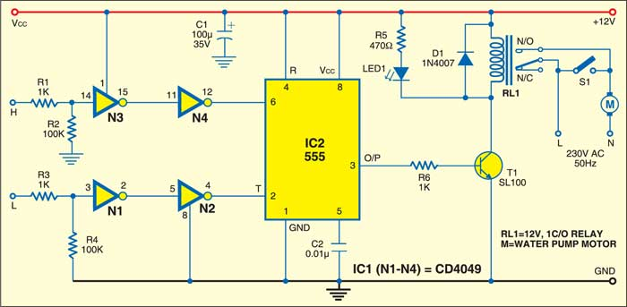
Fig. 1: Simple water level controller
The circuit works off a 12V battery or 230V AC mains using a 12V adaptor. The three sensors built from non-corrosive metal are fitted to the OHT as shown in Fig. 2 and connected to the circuit (Fig. 1) at appropriate terminals. Power supply terminal Vcc is at the bottom of the tank, sensor terminal L is just above the bottom of the tank and sensor terminal H is at the top of the tank. After you have properly installed the sensors in the OHT and connected the power supply, the circuit is ready to use.
Since Vcc terminal is at the bottom of the tank, when the water level falls below sensor L, timer IC2 is triggered at pin 2 via inverters N1 and N2 and its output goes high. As a result, the output of timer IC2 goes high. Relay RL1 energises and the motor starts filling water in the tank. The motor remains ‘on’ even when the water level crosses sensor L.
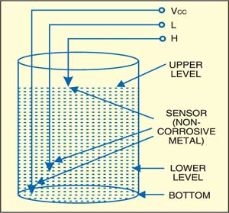
Fig. 2: Sensor installation in the overheadtank (OHT)
As water in the tank rises to touch sensor H, timer IC2 is retriggered at pin 6 via inverters N3 and N4 and as a result, its output goes low. The relay de-energises and the motor stops filling water in the tank. The motor remains ‘off’ even when the water level falls below sensor H.
As water is consumed and its level falls below sensor L, the motor restarts. Thereafter, the cycle repeats.
You can also manually start and stop the motor using switch S1.

Fig. 2: Sensor installation in the overheadtank (OHT)

his inexpensive, fully transistorised switch is very sensitive to sound signals and turns on a lamp when you clap within 1.5 metres of the switch. One of its interesting applications is in discotheques, where lights could be turned on or off in sync with the music beats or clapping.
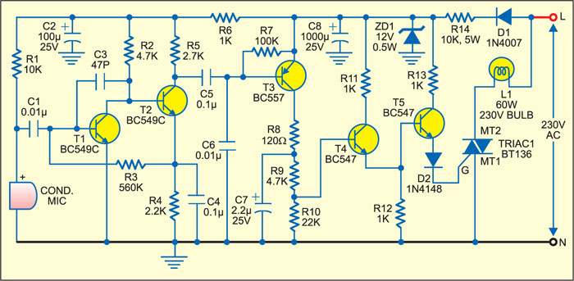
The condenser microphone senses the sound and converts it into electrical variations. The electrical signals are amplified by the two-stage direct-coupled (DC) amplifier formed by transistors T1 and T2 and fed to the switching circuit. The switching circuit comprises transistors T3, T4 and T5, which conduct only when the circuit senses sound signals. Transistor T5 supplies sufficient gate voltage to the triac to drive the 230V lamp.
The regulated 12V DC power supply for the circuit is derived from AC mains by using resistor R14, diode D1 and zener diode ZD1. The circuit can be assembled on any general-purpose PCB.

