Tips, Tricks and Hacks

Tuesday, 25 December 2012

Hack all channels on all types of DTH like Dish TV , Airtel TV, Tata Sky, Videocon etc

DD currently broadcasts 21 of its own TV channels direct to home (DTH) by satellite, and also carries 21 channels from All India Radio, plus 16 private channels. Low carriage rates, when compared to India’s private DTH operators, and a high national reach may attract further broadcasters to the DD platform, ministry officials are reported as claiming.

"This trick provided a free TV channels on your following operator with out Recharge SETUP BOX"
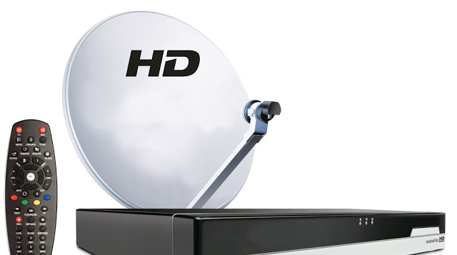

Dish TV
Airtel Digital TV
Tata Sky
Sun Direct
Reliance Digital TV
Videocon D2H
DD Direct
<!--more-->

DTH FREE TO AIR CHANNELS (FTA) IN AIRTEL DTH (AIRTEL DIGITAL TV)

Follow these steeps and watch paid channels in free of cost with out any recharge

You can easily add channels in your Airtel Digital TV STB .

1. Press "menu" button on your ADTV Remote.

2. Go To my settings -> system setup -> free to air channels -> Find Channels

3. Enter following values using your ADTV remote in the FTA SETTINGS FOR SEARCH screen

Satellite: Choose any(Insat 4A ,4B or other)
Search mode: FTA+CAS
Transponder: USER
Modulation type: DVB-S2-QPSK
Frequency:11480
Polarization : VERTICAL
Symbol rate:28800
FEC: 2/3(or any)

All Channels List From Available On Airtel Digital Tv TPs in FTA Reciever.

Scanning 11480 V 28800 8PSK 5/6 ... 90%
-

SONY (TV)

- SET MAX (TV)
- SAB TV (TV)
- ETV Bangla (TV)
- STAR WORLD (TV)
- Life OK (TV)
- STAR PLUS (TV)
- STAR MOVIES (TV)
- STAR GOLD (TV)
- Imagine TV (TV)
- ZEE TV (TV)
- ZEE CINEMA (TV)
- UTV Movies (TV)
- AMRITA TV (TV)
- TEN SPORTS (TV)
- TIMES NOW (TV)
- Aaj Tak (TV)
- ETV Marathi (TV)
- DD Sports (TV)
- DD National (TV)
- COLORS (TV)
- STAR CRICKET (TV)
- Kiran TV (TV)
- Mazhavil Manorama (TV)
- PUTHIYA THALAIMURAI (TV)
- JAYA MAX (TV)
- B4U MUSIC (TV)

[Scanned in 00:05]

NIT: 8 transponders

Scanning 11483 H 25600 8PSK 5/6 ... 88%
-

HELP (TV)

- test3 (Data)
- iDharshan_SES7 (TV)
- iNews_SES7 (Data)
- Test8 (Data)
- CBS SPARK (TV)
- TOPPER (TV)
- Nameless 11483_9605 (TV)
- SAKSHI TV (TV)
- Maa Movies (TV)
- NE Hi Fi (TV)
- CBS Love (TV)
- Gemini News (TV)
- 9X Tashan (TV)
- ZEE TRENDZ (TV)
- HISTORY TV18 (TV)
- SAHARA SAMAY (TV)
- SADA CHANNEL (TV)
- SANANDA (TV)
- CBS PRIME (TV)
- FOODFOOD-SANJEEV KAPOOR (TV)
- SAHARA SAMAY UP (TV)
- SAHARA SAMAY BIHAR (TV)
- FOX CRIME (TV)
- FX (TV)
- Fox Action Movies (TV)
- Ten HD (TV)

[Scanned in 00:05]

NIT: 8 transponders

Scanning 11520 V 28800 8PSK 5/6 ... 89%
- Hungama TV (TV)
- Disney XD (TV)
- Disney Channel (TV)
- KASTURI (TV)
- PROMO BANNER (Data)
- Nameless 11520_3691 (TV)
- Eenadu TV (TV)
- ZEE MARATHI (TV)
- NGC (TV)
- NEWS LIVE (TV)
- HISTORY TV18 HD (TV)
- GAME2 SES7 (Data)
- GAME3 SES7 (Data)
- GAME4 SES7 (Data)
- GAME7 SES7 (Data)
- GAME6 SES7 (Data)
- GAME5 SES7 (Data)
- WB (TV)
- ZEE CAFE (TV)
- Star Cricket HD (TV)
- NGC HD (TV)
- Comedy Central (TV)
- 9X M (TV)
- STAR NEWS (TV)
- Headlines Today (TV)
- CNBC TV18 (TV)
- Chardikala Time TV (TV)

[Scanned in 00:05]

NIT: 8 transponders

Scanning 11520 H 28800 8PSK 5/6 ... 88%
- KTV (TV)
- Sun News (TV)
- Sun Music (TV)
- NE TV (TV)
- Udaya TV (TV)
- Udaya Movies (TV)
- My Account (Data)
- itv portal (Data)
- Dynamic Update (Data)
- Dynamic update2 (Data)
- Airtel Home (TV)
- Help Main App (Data)
- Quickview (Data)
- Airtel Movies 1 (TV)
- Airtel Movies 2 (TV)
- Russia Today (TV)
- CHUTTI TV (TV)
- Games Portal (Data)
- Game 2 (Data)
- Game 3 (Data)
- Game 4 (Data)
- Game 5 (Data)
- Game 6 (Data)
- Game 7 (Data)
- DU PVR (Data)
- Contest Application (Data)
- RUPASHI BANGLA (TV)
- Gemini Movies (TV)
- MH1 SHRADDHA (TV)
- Nepal One (TV)
- DD GUJRATI (TV)
- Landing iNews (Data)
- Landing iDarshan (Data)
- MASTI (TV)
- UTV Action (TV)
- Landing iKissan (Data)
- OTV (TV)
- Zee Talkies (TV)
- SVBC (TV)
- News 24 (TV)
- AXN (TV)
- NEO SPORTS (TV)
- MAA TV (TV)
- DY 365 (TV)
- Tarang Music (TV)
- Rang (TV)
- iKidsworld_Landing (Data)
- Pait Xml (Data)
- iLearn (Data)
- iExam (TV)
- TEN Action+ (TV)
- iExam_trigger (Data)
- Sun TV (TV)
- Landing iDivine (Data)
- iDD Landing (Data)
- Landing iAstro (Data)
[Scanned in 00:05]
NIT: 8 transponders
Scanning 11560 H 28800 8PSK 5/6 ... 88%
- ETV BIHAR (TV)
- ETV RAJASTHAN (TV)
- MH 1 (TV)
- PTC Punjabi (TV)
- ETV-ORIYA (TV)
- Star Pravah (TV)
- Mahuaa TV (TV)
- ETV Urdu (TV)
- ETV Kannada (TV)
- ETV Gujrati (TV)
- SAAM TV (TV)
- PTC CHAKDE (TV)
- ZEE 24 TAAS (TV)
- ZEE 24 GHANTE (TV)
- ZEE CLASSIC (TV)
- Asianet News (TV)
- Jaya Plus (TV)
- TARANG (TV)
- FTV (TV)
- ADITHYA (TV)
- MAKKAL TV (TV)
- SIRIPPOLI (TV)
- Raj TV (TV)
- Gemini Music (TV)
- UDAYA MUSIC (TV)
- Pogo (TV)
- CARTOON NETWORK (TV)
- SANGEET BANGLA (TV)
- ZEE KANNADA (TV)
- ETV2 (TV)
- Surya TV (TV)
[Scanned in 00:05]
NIT: 8 transponders
Scanning 11560 V 28800 8PSK 5/6 ... 89%
- CHANNEL V (TV)
- TV9 Telugu (TV)
- PIX (TV)
- DISCOVERY (TV)
- IBN 7 (TV)
- INDIA TV (TV)
- Aastha (TV)
- Asianet Plus (TV)
- Star Jalsha (TV)
- Jaya TV (TV)
- ISAIARUVI (TV)
- SONY 8 (TV)
- NICK (TV)
- NEO CRICKET (TV)
- Indiavision (TV)
- ANIMAL PLANET (TV)
- STAR SPORTS (TV)
- ESPN (TV)
- MTV (TV)
- CNBC Awaaz (TV)
- NDTV PROFIT (TV)
- ZOOM (TV)
- BINDASS (TV)
- DU SD PVR (Data)
- DU HD (Data)
- Suvarna (TV)
- TEN CRICKET (TV)
- POLIMER (TV)
- Asianet (TV)
- Zee Cinema HD (TV)
- KAIRALI WE (TV)
- PTC News (TV)
[Scanned in 00:05]
NIT: 8 transponders
Scanning 11600 V 28800 8PSK 5/6 ... 87%
- Enterr10 (TV)
- STAR ANANDA (TV)
- Aakash Bangla (TV)
- Manorama News (TV)
- Kalaignar (TV)
- STAR MAJHA (TV)
- ZEE TELUGU (TV)
- ZEE STUDIO (TV)
- Sahara One (TV)
- Sahara Filmy (TV)
- TV 9 KANNADA (TV)
- STAR VIJAY (TV)
- STAR UTSAV (TV)
- ZEE PUNJABI (TV)
- ZEE BANGLA (TV)
- 24 GHANTA (TV)
- KAIRALI TV (TV)
- Gemini TV (TV)
- Gemini Comedy (TV)
- MI Marathi (TV)
- TV9 Gujrati (TV)
- IBN LOKMAT (TV)
- ET Now (TV)
- ETC PUNJABI (TV)
- HBO (TV)
- NTV (TV)
- NDTV India (TV)
- NDTV 24x7 (TV)
- CNN IBN (TV)
- HOMESHOP 18 (TV)
- Max HD (TV)
[Scanned in 00:05]
NIT: 8 transponders
Scanning 11600 H 28800 8PSK 5/6 ... 85%
- CAPTAIN TV (TV)
- INDIA NEWS (TV)
- DAY & NIGHT NEWS (TV)
- E24 (TV)
- LIVE INDIA (TV)
- test4 (Data)
- JEEVAN (TV)
- TV5 (TV)
- BHAKTI TV (TV)
- PARAS (TV)
- SADHNA TV (TV)
- SUVARNA NEWS (TV)
- VASANTH (TV)
- DISCOVERY SCIENCE (TV)
- DISCOVERY TURBO (TV)
- UDAYA COMEDY (TV)
- MOVIES NOW (TV)
- KOLKATA TV (TV)
- CBEEBIES (TV)
- BBC ENTERTAINMENT (TV)
- Nameless 11600_4159 (TV)
- Airtel Movies 3 (TV)
- Maa Music (TV)
- SONY MIX (TV)
- iKidsworld (TV)
- Gamezone (TV)
- My Offer (TV)
- launchidarshan (Data)
- launchgamezone (Data)
- iRadio (Data)
- STAR GOLD HITZ (TV)
- iAstro_SES7 (Data)
[Scanned in 00:05]
NIT: 8 transponders
Scanning 11640 V 28800 8PSK 5/6 ... 87%
- STAR PLUS HD (TV)
- STAR GOLD HD (TV)
- STAR WORLD HD (TV)
- STAR MOVIES HD (TV)
- UTV ACTION TELUGU (TV)
- DD Loksabha (TV)
- DD Rajyasabha (TV)
- DD BHARATI (TV)
- DD Gyandarshan (TV)
- COLORS HD (TV)
- DISHA TV (TV)
- MOVIES NOW HD (TV)
- DISCOVERY HD WORLD (TV)
[Scanned in 00:05]
NIT: 8 transponders
Scanning 11644 H 24000 8PSK 5/6 ... 84%
- Sonic (TV)
- Janasri (TV)
- Granada TV (TV)
- Frontier (TV)
- MYTV (TV)
- Fundaa's Quiz (Data)
- Fun Zone (Data)
- iKidsworld_Portal (TV)
- Zee Salaam (TV)
- ESPN HD (TV)
- Dangal (TV)
- Zee Premier (TV)
- IEXAM (Data)
- IEXAM_DUMMY (Data)
- UTV Stars (TV)
- ZEE TV HD (TV)
[Scanned in 00:05]
NIT: 8 transponders
Scanning 11680 V 28800 8PSK 5/6 ... 83%
- VH1 (TV)
- ETC (TV)
- Bloomberg-UTV (TV)
- ZEE NEWS (TV)
- ZEE BUSINESS (TV)
- iNews invite (Data)
- DD PUNJABI (TV)
- DD Bangla (TV)
- UDAYA NEWS (TV)
- CNN (TV)
- DD Kashir (TV)
- DD Oriya (TV)
- Fox Traveller (TV)
- ETV UP (TV)
- CNEB News (TV)
- DD Urdu (TV)
- TLC (TV)
- BBC WORLD NEWS (TV)
- UTV World Movies (TV)
- DD News (TV)
- DD Podhigai (TV)
- ETV MP (TV)
- DD Chandana (TV)
- DD Sahyadri (TV)
- MGM (TV)
- NDTV Good Times (TV)
- iDD (TV)
- iDD_Trigger (Data)
- Taaza Tv (TV)
- DD MALAYALAM (TV)
- iDD South (TV)
- DD Sapthagiri (TV)
- iDD South_Trigger (Data)
- DD NORTH EAST (TV)
- ANGEL TV (TV)
- GOD TV (TV)
- SHALOM (TV)
- SUBHAVAARTHA (TV)
- JaiHind (TV)
[Scanned in 00:05]
NIT: 8 transponders
TPs with no signal: 0
Empty: 0
Nameless: 3
Elapsed: 01:04
Video Channels: 282
Radio Channels: 0
Data Channels: 49
Total: 331
Scan completed.
Every time select User as a transponder and FTA+CAS as a search mode. Save all channels and you can view these channel after channel no. 1500 .
If it is working for you don't forget to Subscribe our update
This blog has been copid from http://www.alltricksworld.in/ website and i dont owe any copyright
Posted by Charanjeev Singh Bagga at 23:27
Email ThisBlogThis!Share to TwitterShare to Facebook

63 comments:
Pranjal Maini9 February 2013 09:11
nope, not working on airtel (now atleast)
Reply
Pranjal Maini9 February 2013 09:46
Can't set the Symbol rate:28800
instead it can be set as 28.80
and so, thats not working
Reply
Raes Raaz21 March 2013 05:09
there is no audio and video
Reply
sanjay kumar kashyap22 March 2013 13:16
Not working,blank screen.pls help
Reply
sanjay kumar kashyap22 March 2013 13:17
blank screen.pls help
Reply
sanjay kumar kashyap22 March 2013 13:22
Not working,blank screen.pls help
Reply
Anonymous23 March 2013 06:58
a black screen only no video or audio on ADTV
Reply
Replies
Anonymous6 November 2013 04:06
ur correct
Reply
chauhan ketan6 April 2013 23:57
not work bro.....
Reply
chauhan ketan6 April 2013 23:58
not work bro.....
Reply
Anonymous11 April 2013 02:42
hi this hack is not working please post a fresh and working hack
Reply
Anonymous12 May 2013 22:14
I was more than happy to search out this
net-site.I wanted to thanks for your time for this wonderful
learn!! I undoubtedly having fun with each
little bit of it and I have you bookmarked to check out new stuff you
weblog post.
my webpage accomodation Alicante
Reply
Anonymous16 May 2013 17:13
I’m not that much of a internet reader to be honest but your
sites really nice, keep it up! I'll go ahead
and bookmark your site to come back down the road. Cheers
My blog post http://Www.Thespainforum.com
Reply
Anonymous16 May 2013 17:13
naturally like your web-site but you need to check the
spelling on quite a few of your posts. A number of them are rife with spelling issues
and I find it very troublesome to tell the truth nevertheless I will surely come
back again.
Feel free to visit my web site :: Plan
Reply
Sagar Jaiswal18 May 2013 03:39
its working 100% dude thnx.............
Reply
Replies
Anonymous30 October 2013 12:56
video con hai kya tumhare pas
Reply
Sagar Jaiswal18 May 2013 03:40
its working 100% dude thnx.............
Reply
Replies
  - 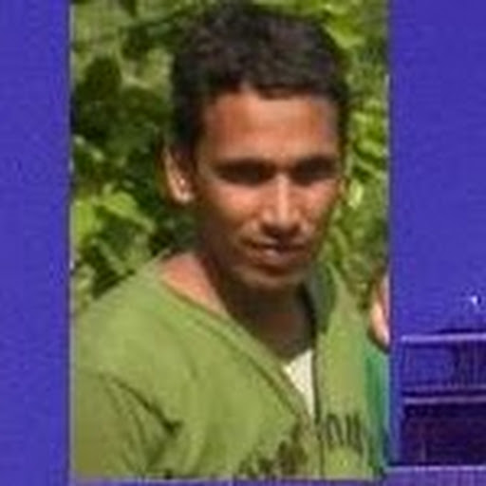
brijbhan singh22 July 2013 20:16
sagar jaiswal ji plz can you give a miss call i can call you my phone no. is 07672-290402
Hasmukh Patel28 September 2013 21:23
sagar plz can you give one miss call plz plz my no 0823-870-6700
Reply
Anonymous18 May 2013 04:23
are iski ma ka
Reply
Suhas Bobby18 May 2013 20:45
blak screen coming
Reply
Anonymous22 May 2013 03:22
I’m not sure where you are getting your info, but good topic.
I needs to spend some
time learning more or understanding more. Thanks for magnificent
info I was looking for this info for my mission.
Have a look at my webpage ... HTTP://www.Thespainforum.com/
Reply
Anonymous22 May 2013 03:22
Wow, marvelous blog layout! How long have you been blogging for?
you make blogging look easy. The overall look of your web site is
fantastic, as well as the content!
Here is my weblog Thespainforum.com
Reply
Anonymous5 June 2013 06:24
Only those Channels which are in current subscription work. Others are just black screens. No a/v.
Reply
Anonymous22 June 2013 04:14
working bro thanx
Reply
Replies
brijbhan singh22 July 2013 20:12
This comment has been removed by the author.
brijbhan singh22 July 2013 20:14
plz brother tell me about setupbox my phone no is 07672-290402
Reply
brijbhan singh22 July 2013 20:09
not working only 999 channel capacity of dd dth reciver
Reply
sandeep23 July 2013 07:08
This is impossible! I mean how someone hack the whole system, nevertheless I would like to follow your steps. Let's see its working or not. I'll be right back.
Reply
REMEESH VARMKADAVU24 July 2013 02:31
its not working properly black screen comin pls halp me
Reply
Anonymous25 July 2013 06:45
Videocon DTH box this tricks working or not ???
Reply
Anonymous25 July 2013 06:46
Videocong DIGISTB1111-U DTH box this tricks working or not ?? pls reply me bro
Reply
Bhupendra Kr.13 August 2013 04:30
On internet,there is an abundance of blogs of tricks for 3G and DTH services.Airtel has provided cheap 3G DTH plans for its customers.
Reply
Anonymous16 August 2013 20:44
Only the first frequency 11480 works , other values don't work in my place, Assam. How can I get the other channels mentioned by you?
Reply
mohammed khandwawala17 August 2013 01:00
not working in videocon d2h
Reply
mohammed khandwawala17 August 2013 01:03
not working in videocon d2h
Reply
Anonymous19 August 2013 02:31
Teri Ma ka sale kuchh bhi batata hai kamina chutiya saala
Reply
Anonymous28 August 2013 21:41
IS IT WORK IN TATA SKY OR NOT. SYMBOL RATE DOES NOT SET.IF IT IS POSSIBLE THAN HELP ME..
Reply
Administrator30 August 2013 21:03
kya dishtv se saare free2air channel without payment dekhe ja sakte hain or uski setting kya ai
Reply
abhishek salkar2 September 2013 02:17
friends ye trick use karke paise kama sakte ho easily sirf ye link open karke sign up karo
http://Money4Refer.com/index.php?refcode=211594
Reply
Anonymous20 September 2013 01:31
working Great!!!! :) :)
Reply
Anonymous28 September 2013 20:04
goobadyy
Reply
Anonymous30 September 2013 22:55
its not working.....:(
Reply
Anonymous16 October 2013 02:15
don't wate your time. it's fake fake fake................
Reply
Anonymous17 October 2013 13:24
ghta channel to koi aaye ni aur settop box aur hang ho gya . .salla.. eski maa ki aankh.. :P Farzi kahi ka.. :P
Reply
Anonymous23 October 2013 02:22
behen ke loode teri maa ki choot.
Reply
073786fe-46ca-11e3-a938-000bcdcb8a736 November 2013 01:58
nothing came
Reply
Anonymous6 November 2013 04:05
itz not working buddy...!
Reply
- 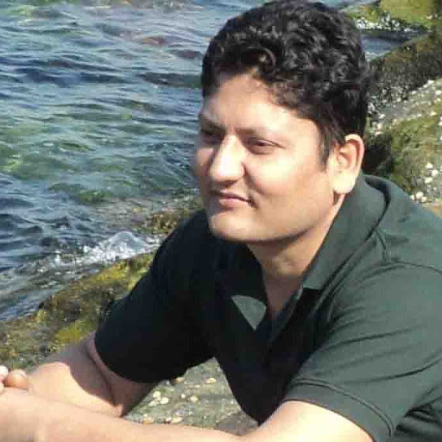
Kishor Kc10 November 2013 06:12
Plz don't publish like this cheap post..." Public hai sub janti hain"
Reply
Anonymous14 November 2013 01:39
Kya aisa karna legal hai. Pata chala channel to on kar liye aur baithe hai lockup me. Confirm dude "Is this legal?"
Reply
Anonymous26 November 2013 10:35
abe o work nahi karta..to fikar matkar to jail nahi jaye ga ha ha
Reply
Anonymous1 December 2013 00:13
wow amazing , working
Reply
Anonymous9 December 2013 18:02
Mother fucker is cheating u all.
Reply
Anonymous12 December 2013 08:38
Post karne wala apni ma ke gaand se paida hua hai... Chodu chala hai hacker banne..
Reply
Anonymous14 December 2013 00:58
Brother not working post a fresh idea
Reply
md. saleh abdullah al ssyeem21 December 2013 02:52
it's not working on airtel sd receiver ............ have any other idea?
Reply
Anonymous27 December 2013 20:15
CHUTIYA BANA RHA HAI BEHAN KA LODA
Reply
Anonymous28 December 2013 07:23
Dhi ka Land Logon Ka Time Vest Kar Raha Hai.....Bhai Atto Scan Hi Theak Hai.....
Reply
Anonymous6 January 2014 23:49
can i use this trick in airtel tv tell mee pls
Reply
harish7 January 2014 07:41
It's not working http://urlsaf.com
Reply
harish7 January 2014 07:42
No audio bro...Plz updateee http://urlsaf.com
Reply
Anonymous24 January 2014 01:12
bagga hijda
Reply
Anonymous25 January 2014 05:57
Frineds,if you want to get free mobile recharge,just register on this site
http://mcent.com/ref/KHFKHK/
Reply
Newer PostOlder PostHome
Subscribe to: Post Comments (Atom)

Blog Archive
- ► 2013 (1)
- ▼ 2012 (7)
  - ▼ December (7)
    - Hack all channels on all types of DTH like Dish TV...
    - Download and register Winamp Pro for free
    - Tutorial to fix openGl 2.0 ,1.4,1.3 for window 7 3...
    - UDIDfaker : Legit or Fake (App Trailers) ??
    - Download Cool Toolbar Icons for IDM(Internet Downl...
    - Change Toolbar icons of Internet Download Manager
    - Customize iTunes 11 or 11.xx to get "transfer purc...

About Me
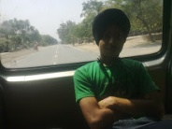
Charanjeev Singh Bagga
Myself Bagga and i have created this blog to share some tricks and hacks known to me. i also posted some softwares which are very useful and can be downloaded without paying a single penny... Dont forget to join me on YouTube and Facebook :D
View my complete profile
Bagga. Awesome Inc. template. Powered by Blogger.

